**SQL Assignment 3**

**1. write a SQL query to find Employees who have the biggest salary in their Department**

select emp_id, emp_name, dept_id, salary from employee where salary IN (select max(salary) from employee group by dept_id) ;

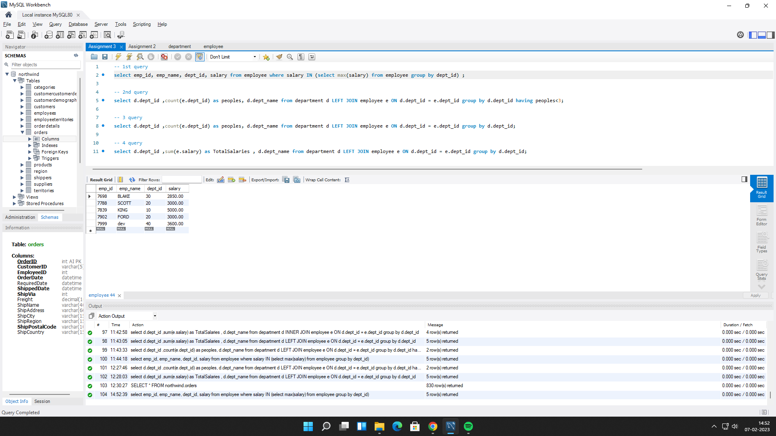

**2. write a SQL query to find Departments that have less than 3 people in it.**

select d.dept_id ,count(e.dept_id) as peoples, d.dept_name from department d LEFT JOIN employee e ON d.dept_id = e.dept_id group by d.dept_id having peoples<3;

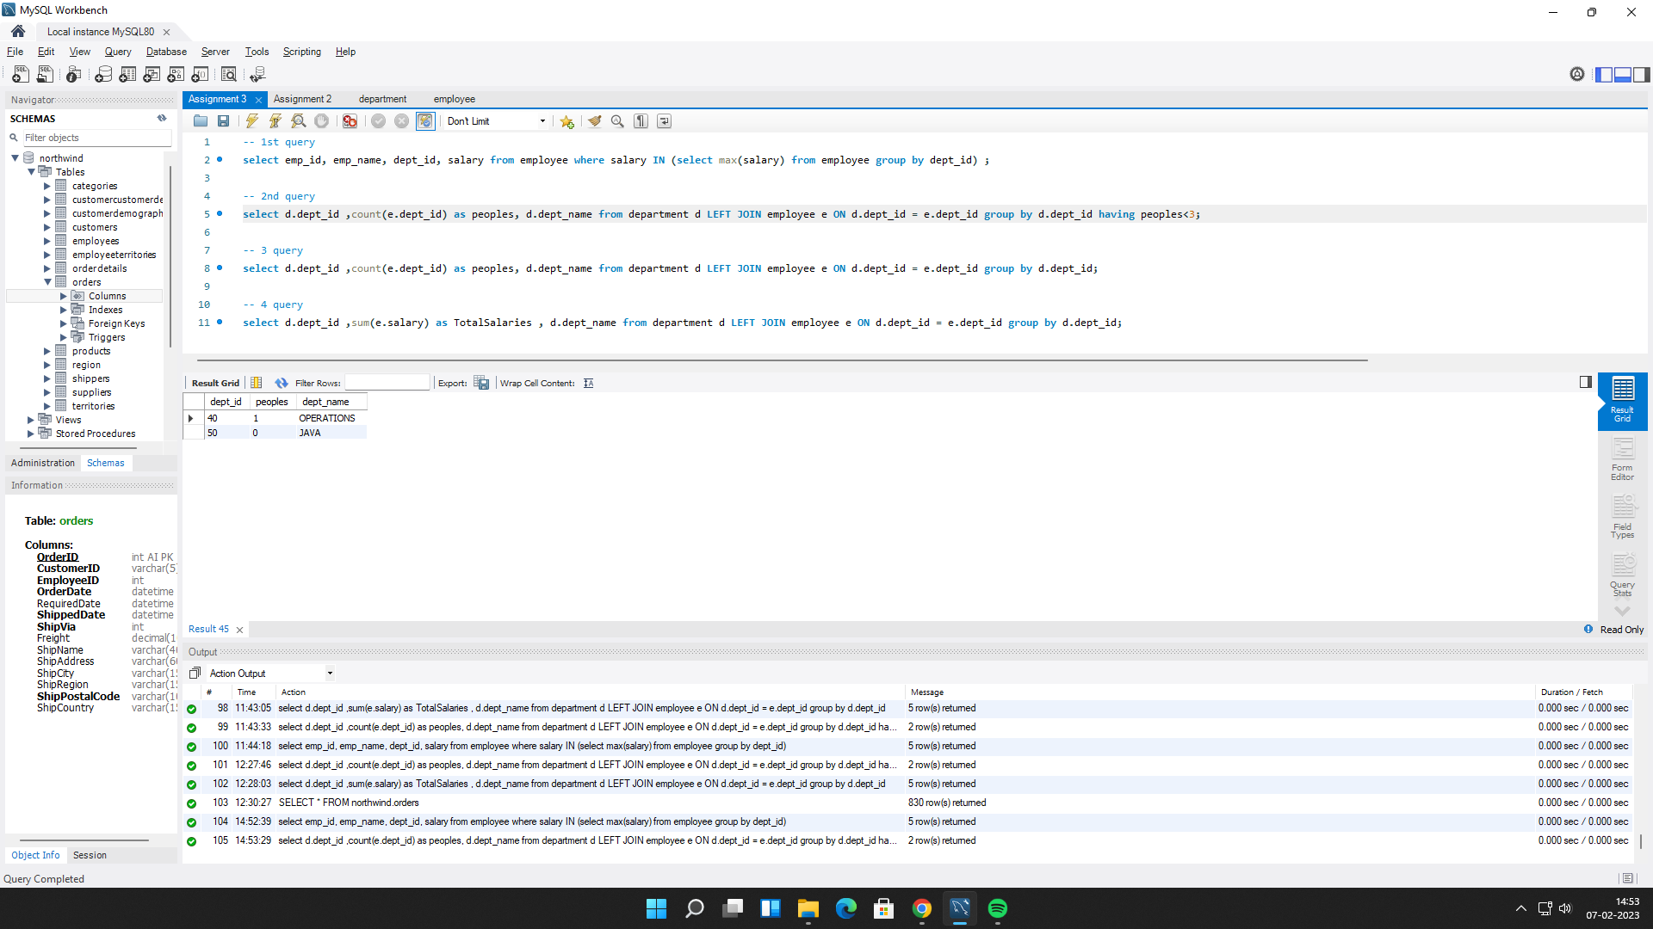

**3. write a SQL query to find All Department along with the number of people there.**

select d.dept_id ,count(e.dept_id) as peoples, d.dept_name from department d LEFT JOIN employee e ON d.dept_id = e.dept_id group by d.dept_id;

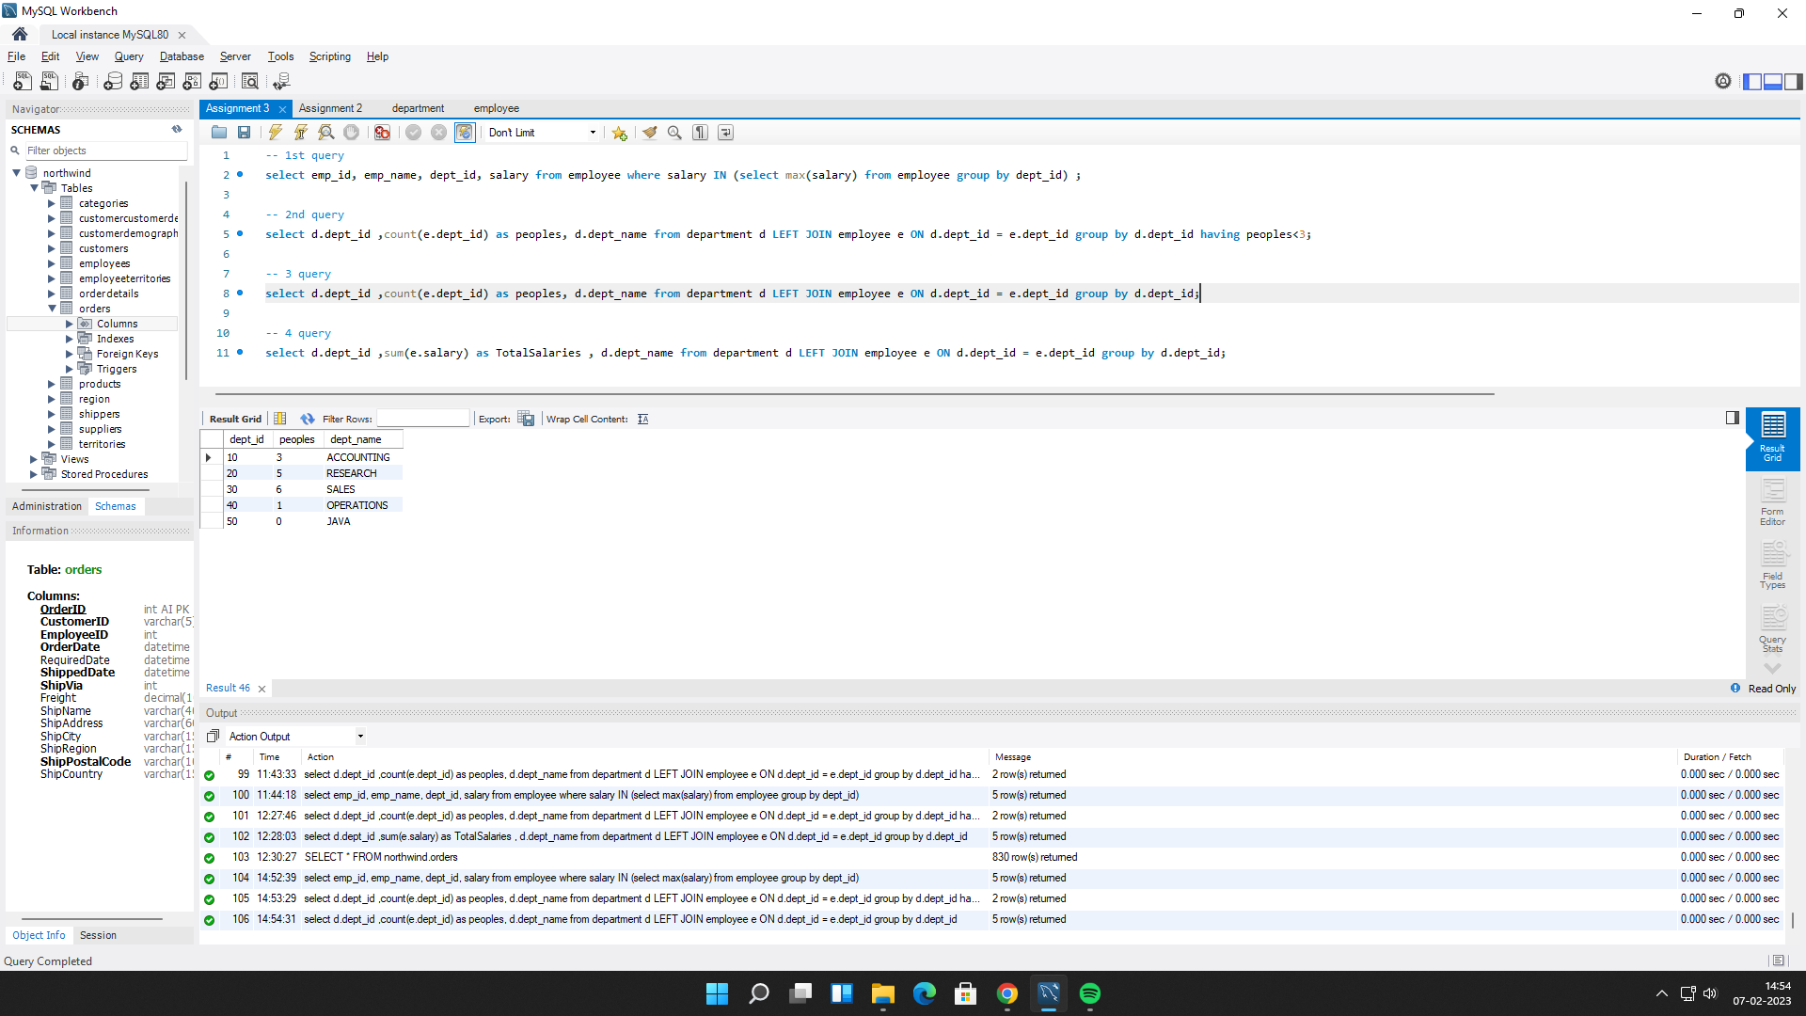

**4. write a SQL query to find All Department along with the total salary there.**

select d.dept_id ,sum(e.salary) as TotalSalaries , d.dept_name from department d LEFT JOIN employee e ON d.dept_id = e.dept_id group by d.dept_id;

